ASR 3639 – 2012-06-20
CHWDD shipment:
Add input validation:
1) POD date cannot be earlier than AF Date
2) AW date cannot be earlier than Received Date

Deployed Changes: - 2 Jul 2012
AW Date validation
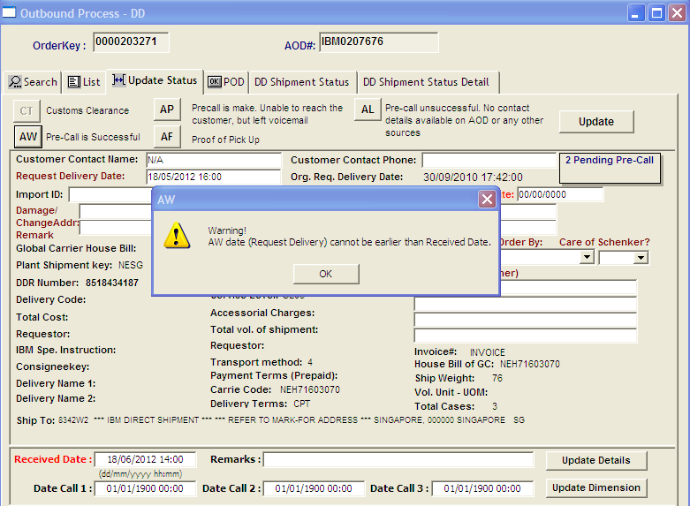

POD Date validation:
